***PLANT A LIVING WALL***

Vertical space is used in different ways in the garden. I loved this edible bench with its mix of viola, sage, curry plant, parsley and oregano. In reality, few of us are likely to have an entire outside bench covered in edibles. More achievable are the inexpensive hanging pockets which can be attached to the wall and filled with edible plants. I liked the way a variety of greens are used here with the silvery curry plant (Helicrysum italicum), dark sage and bright green parsley. The white and blue violas add a sprinkle of colour and their petals can also be used in ice cubes, on salads or crystallised in cakes.

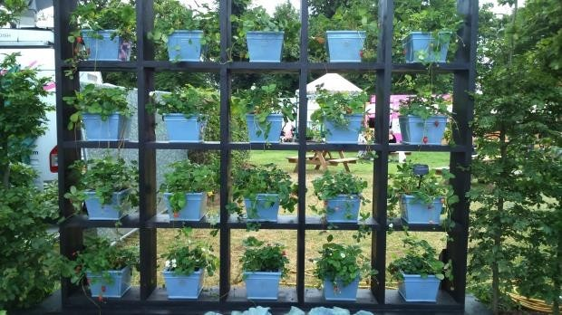

A simple wall storage unit filled with strawberry pots

This storage unit looks great and something similar (possibly smaller) should be fairly easy to buy or construct and then treat with weatherproof paint, although a piece constructed specifically for outdoor use would no doubt have a longer life. In fact, I’m tempted to throw the children’s toys out of our similar unit and relocate it on the patio as a way of gaining more planting space in the garden!

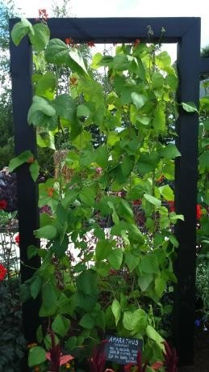

This runner bean wall is another way to capitalise on the vertical space against a sunny wall. With wires between the top and bottom frames, the beans can very quickly cover the wall and could be planted in pots or the ground. A simple cane structure could also be used, although this metal frame would be strong and durable, and could be removed in the winter months. For added variety, the beans could be interspersed with morning glory (Ipomoea purpurea), black-eyed Susan (Thunbergia alata) or sweet peas to add (non-edible) annual colour to the display. This method of growing could also be used with peas or even courgettes, cucumbers and squashes, which love to climb and welcome the extra sunshine accessible in an elevated position. In this way, crops can be grown which otherwise might struggle for space in a small garden.